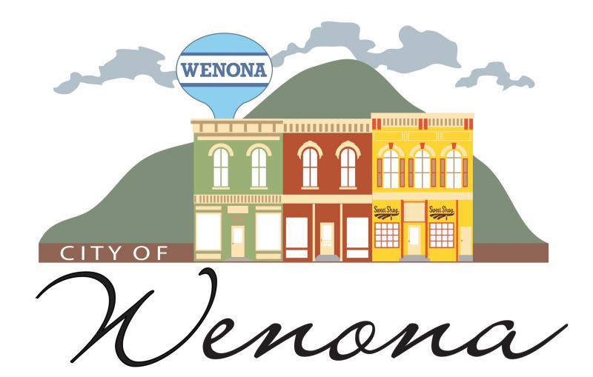
Demo Permit 3-2A-1
City of Wenona
226 Chestnut Wenona, IL 61377
815-853-4227 FAX 815-853-0006
Mike Breyne: 815-257-4132 Zoning Director

Date ____________________ Permit# ______________
Name _________________________________Address ______________________________ Phone ________________
Contractor Name : _____________________________ Phone # _____________________________________________
Estimated cost $___________________________________ Permit Fee $35.00 Cash ___________ Check # _________
Name & Address of Contractor ______________________________________________________________________
Copy of Contractors Insurance ____________ (Copy) Contractor must follow EPA regulations.
Owner Signature __________________________________Date _____________________________________________
Zoning Director Signature ___________________________Date _____________________________________________
A. Required: It shall not be lawful to construct, alter, repair, remove or demolish, or to commence the construction, alteration, removal or demolition of a building or structure without first filing with the building inspector an application in writing and obtaining a formal permit.
Please draw map of proposed construction

